**EGNSS** and agriculture – a win-win relationship

***Published:***

*19 December 2019*

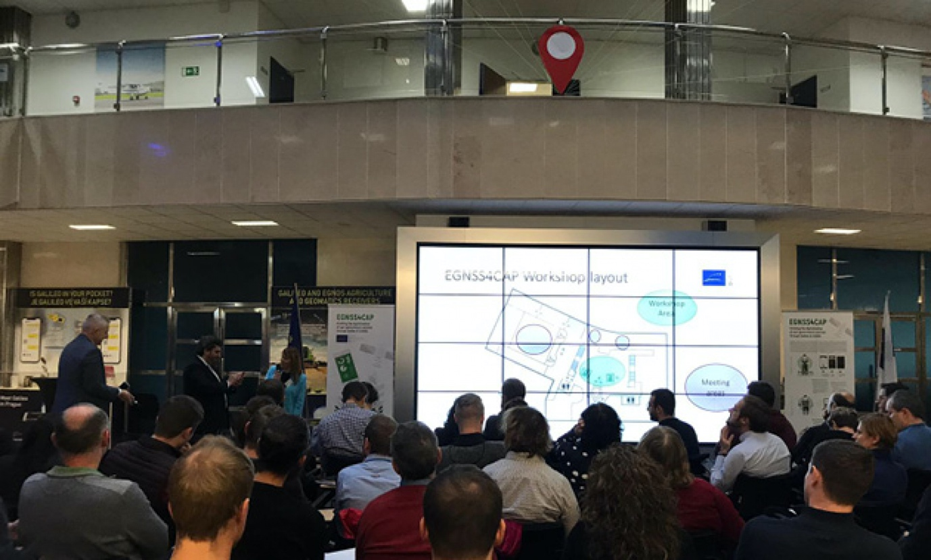

*GNSS supports precision agriculture and a more efficient implementation of the CAP*

**GNSS is a key enabler of precision agriculture, allowing farmers to drive their tractors along parallel lines, avoid overlaps and gaps in field cultivation, and reduce their fatigue thanks to satellite-enabled autopilot. GNSS also helps to reduce agriculture’s ecological footprint – a win-win situation for society as a whole. Thanks to Galileo´s dual frequency and authentication capability, it can also help farmers and authorities in the frame of the Common Agricultural Policy (CAP).**

Speaking at the [EGNSS4CAP](https://www.egnss4cap.eu/) Workshop, a part of the 25th JRC MARS Conference in Prague on 29 November, European GNSS Agency Executive Director Carlo des Dorides said that for 10 years already EGNOS had been providing farmers with an affordable precision agriculture entry solution, delivering metre-level accuracy over Europe free of charge.

He noted that equipment manufacturers had been quick to realize the benefits of EGNOS, and that over 90% of new tractors in Europe are currently equipped with EGNOS receivers. “Galileo also offers several services that the agriculture community can benefit from – the Open Service is already improving positioning and navigation, especially thanks to dual frequency. It will be complemented by the High Accuracy Service that will provide around 20-cm accuracy free of charge and the Authentication Service that will reduce risks associated with spoofing,” des Dorides said.

**Space synergies**

On its own, GNSS provides considerable benefits to farmers, but it is when it works in synergy with the EU Earth observation programme Copernicus that the EU space programmes really deliver. “EGNSS and Copernicus are two pillars that play a crucial role in achieving sustainable agriculture,” des Dorides said. “In particular, the satellite programmes play a crucial role in the Common Agricultural Policy, delivering significant added-value for farmers, the institutions involved and society at large,” he said.

**Read this:** [EU Space Week 2019: Sustainability and Space](https://www.gsa.europa.eu/newsroom/news/eu-space-week-2019-sustainability-and-space)

One application that exploits synergies between EGNSS and Earth observation is EGNSS4CAP. This is an Android smartphone app that enables EU farmers to digitalise procedures related to their reporting requirements under the current and post-2020 CAP. The application will enable farmers to provide geo-tagged photos to support and complement a Copernicus-based monitoring approach to CAP. It uses the Galileo differentiators, Open Service Authentication and dual frequency, and can help authorities and farmers to reduce bureaucratic burden and duplications, as well as improve performance and reliability.

**Implementing CAP**

“GNSS and Copernicus are the core components in the digital farming ecosystem (Agriculture 4.0) and the main contributors to the modernised CAP,” Fiammetta Diani, the GSA’s Head of Market Development said at the conference.

For example, satellite-based monitoring procedures can reduce the need for On-The-Spot Checks (OTSC) for area-based CAP payments (EU subsidies related to the area and type of crop). The Galileo-based geo-tagged photo application provides the location and timing of the photo, leveraging Galileo’s dual-frequency and authentication features to provide higher accuracy and authentication for reporting to the paying agencies. The application is freely and openly available for any institution or company that would like to integrate it in their own solutions.

In this way, EGNSS is helping to support efficient operations in one of the key areas of the EU economy. The CAP impacts almost 10 million people working in agriculture and has a proposed budget of EUR 365 billion for 2021-2027, accounting for about one-third of the total EU budget.